Flex

For Student and Teachers

FAST-NU

Object Oriented Analysis and Design CS-D

*Submitted By*

*Haider Wain 17L-4060*

*Basim Ahmed 17L-4022*

*Hassaan Zulqarnain 17L-4534*

*Umar Azam 17L-4506*

*Omer Asif Khan 17L-4324*

*Hamza Naseem 17L-4073*

# Updated Class Diagram

Following is our updated class diagram (design level)

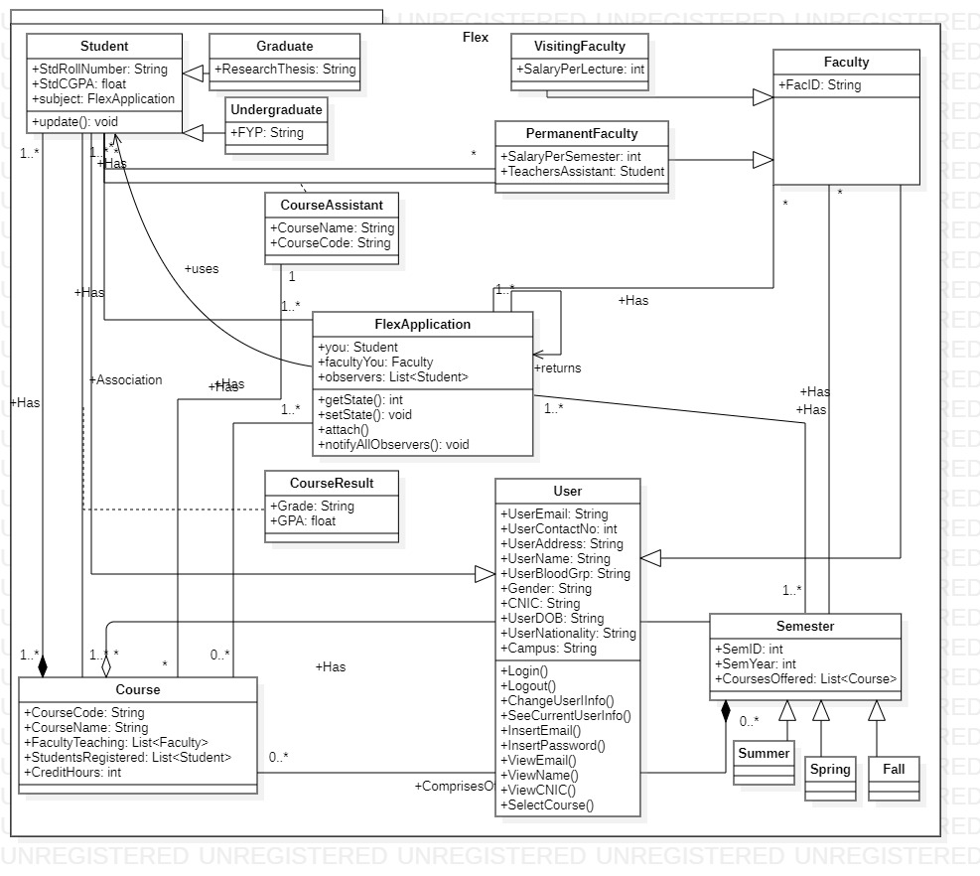

# Design Decisions

Following are our design decision as per group member.

1. **Umar Azam**

**Student:**

Student (a subclass of user) is the class who is main focus of our project. Along with the basic demographics inherited by User, Student has 2 more attributes: A Roll Number and a CGPA. Student has two subclasses namely Graduate and Undergraduate both of which have an extra attribute Research Thesis and FYP respectively. The Student class can Register courses, View Transcript, Check Attendance, Check Marks, Drop a course, View registerable courses, Print a Challan Form and Check his/her fee details. These methods are all related to a Student and ergo, added in the Student class. Student class is responsible for all the methods and attributes related to a Student.

1. **Haider Wain**

**Faculty:**

Faculty class manages the faculty staff at NUCES. There are two types of faulty, Visiting faculty which are differentiated from the other type, Permanent Faculty, by salary and working hours. Visiting faculty do not have any office hours and are given salaries per lecture given. On the other hand, permanent faculty have offices in the campus with allotted office hours that they have to serve. Permanent faculty are also giving the power to hire teacher assistants and research assistants. Both types of faculty can use Flex.com to view/add student attendance, upload/edit marks of their students, and view students’ information regarding the subject.

1. **Basim Ahmed**

**User class:**

User is the base class for all actors in the system “FLEX”. The point of having a user class is because both the student and the faculty same some common attributes and therefore to save space and make our program more efficient we have implemented a User class. The user class stores basic information of any person that is registered to the system. Information such as their name, email ID, contact information, gender, nationality etc. The methods of the user class are to verify login of a user and determine whether the password entered is correct or incorrect. It gives the user to modify the details about themselves that they wish to change. User class gives the ability for a person to change their password, their contact number, their current address and other information. The User class is the parent class of Student and Faculty and these respective classes get their basic attributes inherited from the user class.

1. **Omer Asif Khan**

**Semester and Sub-classes:**

Semester class in our FLEX application manages the current semester information as well as the previous semesters. This class is associated with Course class, because we need to keep a List of courses offered this semester. Semester can be of 3 types, Summer semester, Spring semester, and fall semester. List of course offered in these semesters will be different.

1. **Hamza Naseem**

**Course class:**

Course class in FLEX application is to keep track of each course and the instructors that are associated with it. Students also communicate with course class, because every student in the university has at least one course. Each course keeps track of the instructor that is teaching the course, and the students registered in the course.

1. **Hassaan Zulqarnain**

**Flex Application:**

All main classes Faculty, Student, Course and Semester are associated Flex application class as it is the base class of our application system. It contains a list of users who are currently logged in the application.

**Course Assistant:**

This class is an association class between Student and Permanent Faculty classes. It has an association with course class. It contains a sting to store the name of the course assistant and a string for the course code for which the student is an assistant of. As it is an association class, it means only one student can be a course assistant at one time.

**Course Result:**

This is an association class between Student and Course classes. It contains a string to store the grade of the particular student for a specific course and the GPA the student obtained in that course. This shows that there can exist only one result of a student for a specific course.

# Sequence Diagrams

Following our sequence diagrams (3 per group member).

1. Umar Azam
2. Check Attendance (Student)

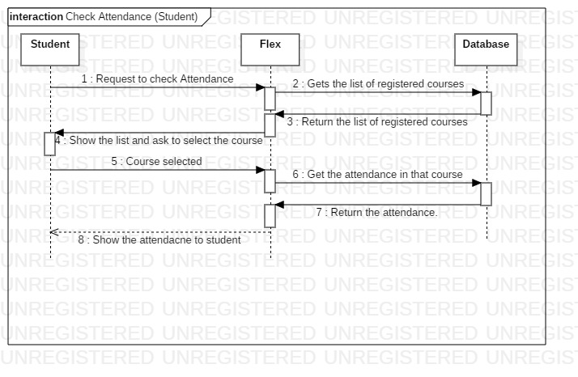

1. Upload Marks (Teacher)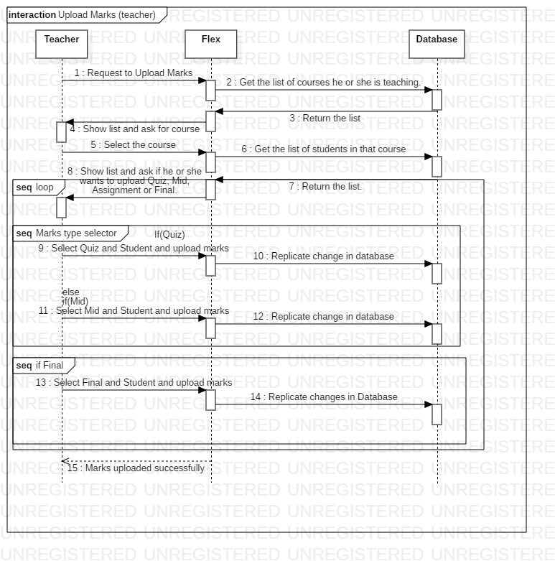
2. Edit Marks (Teacher)

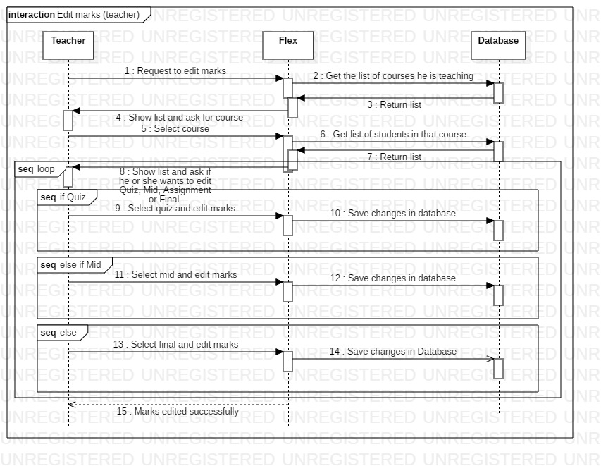

1. Haider Wain
2. Login

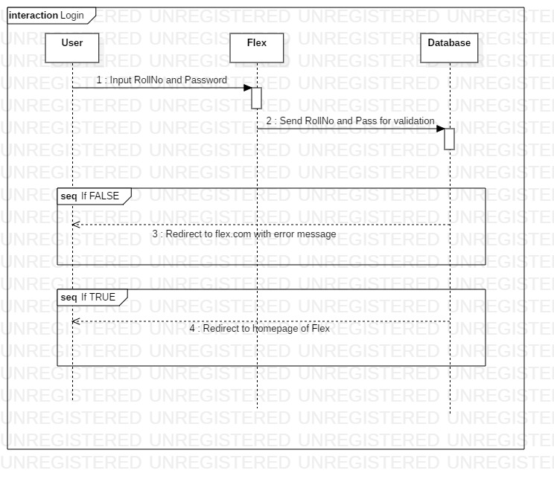

1. Logout

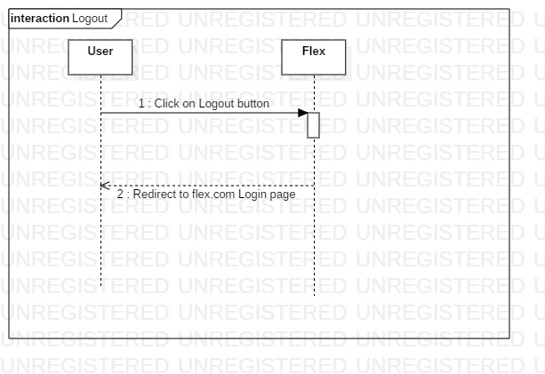

1. Change User’s info

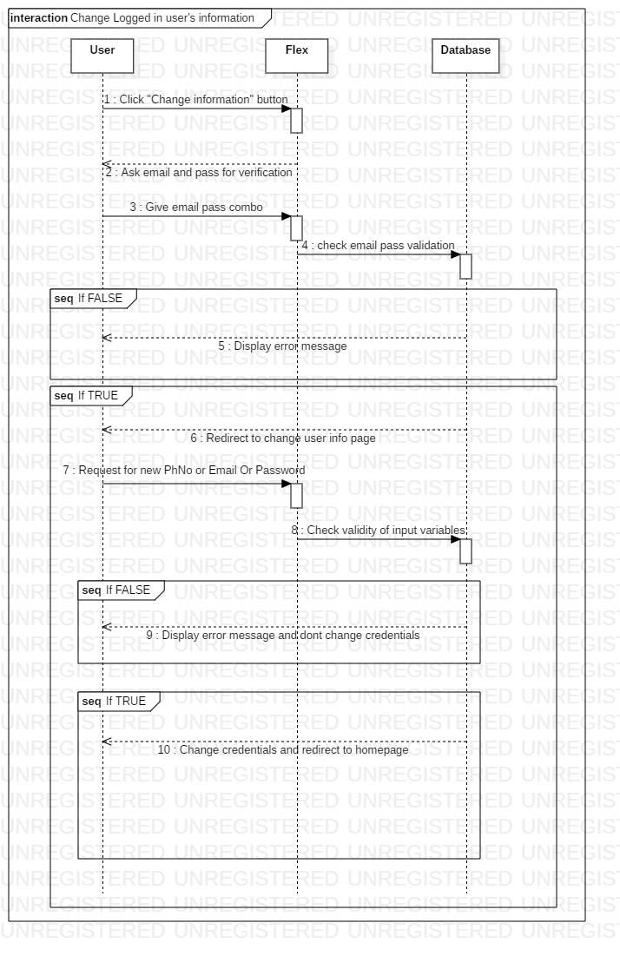

1. Basim Ahmed
2. Print Challan

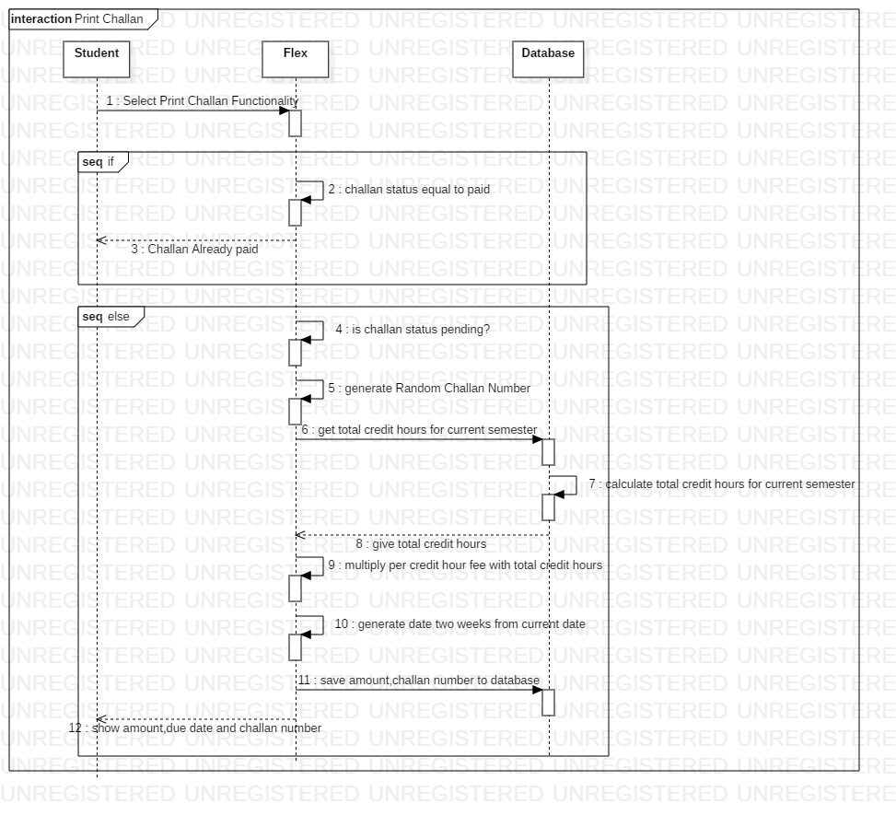

1. Check Transcript

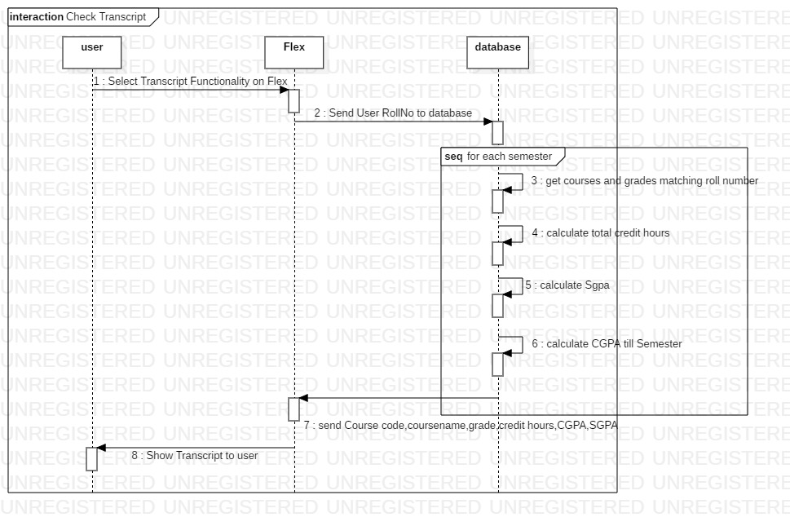

1. Fee Details

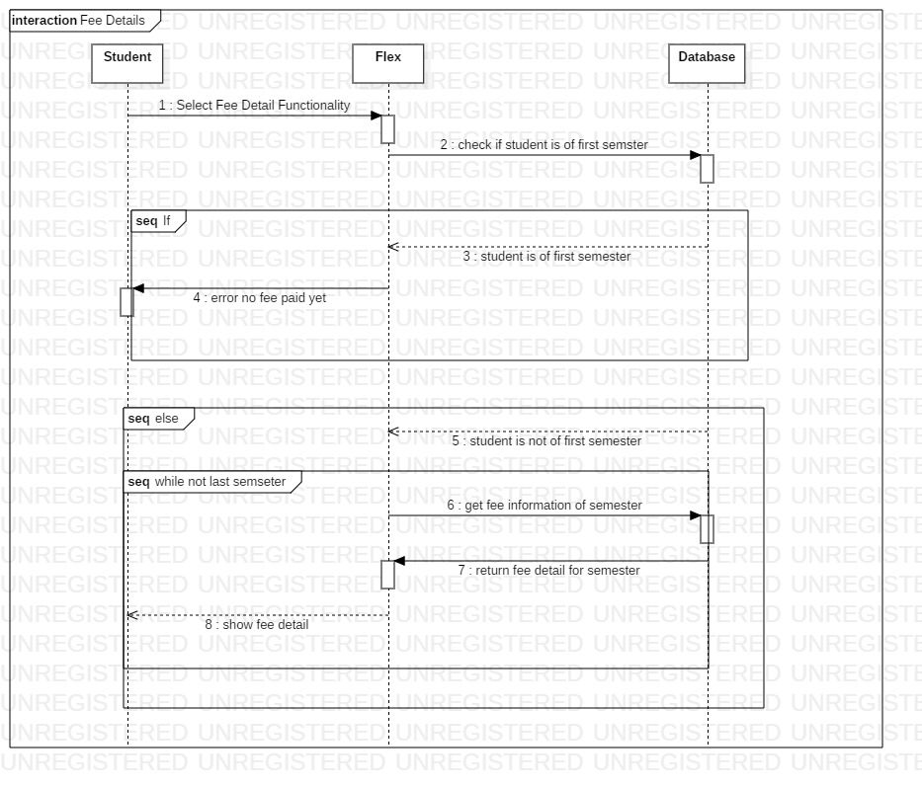

1. Omer Asif Khan
2. Register Course

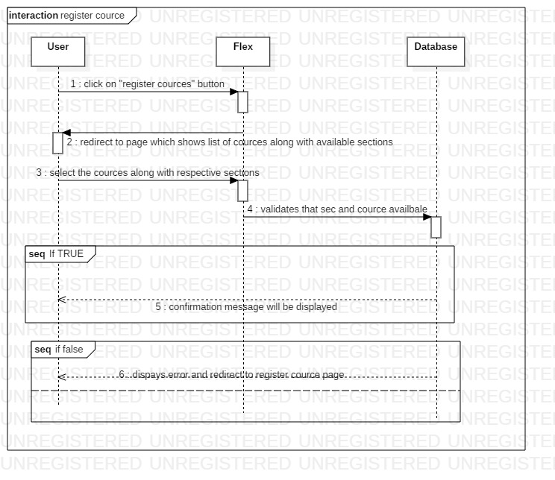

1. Drop Course

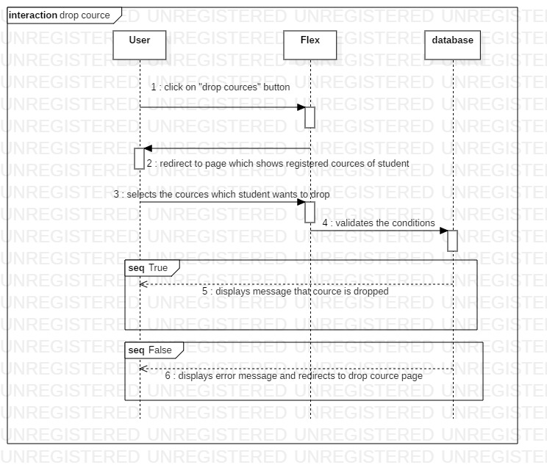

1. View Marks

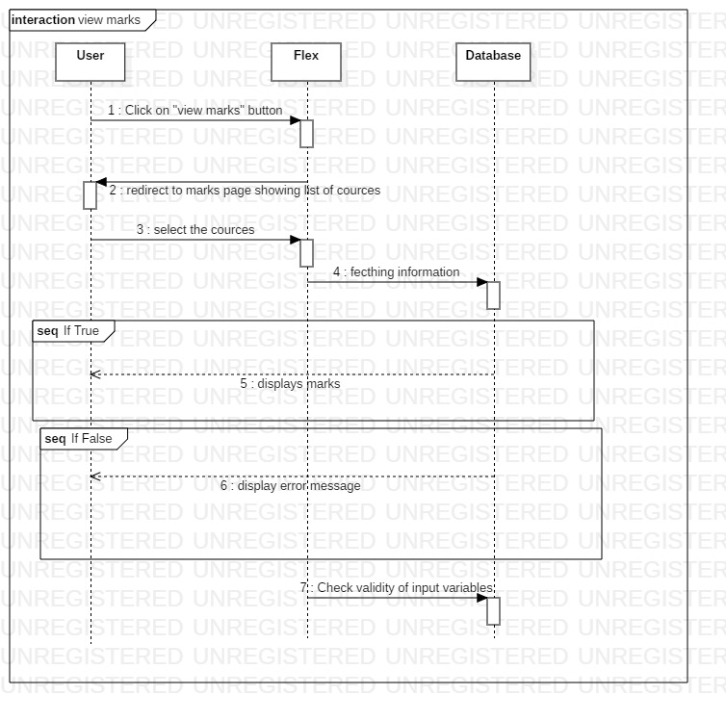

1. Hamza Naseem
2. Check Attendance

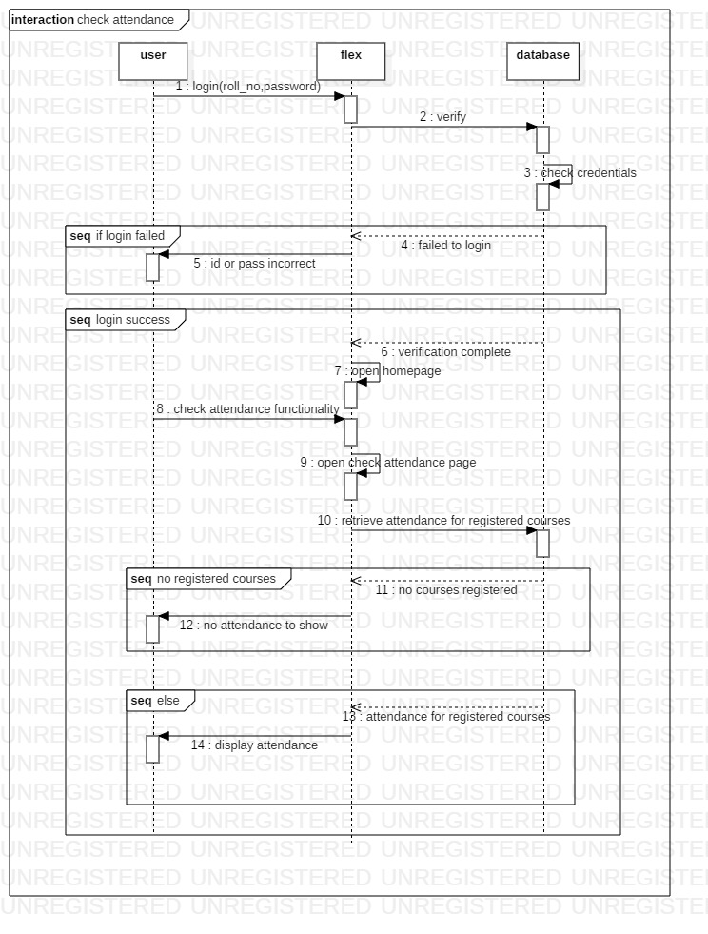

1. View Registered Courses

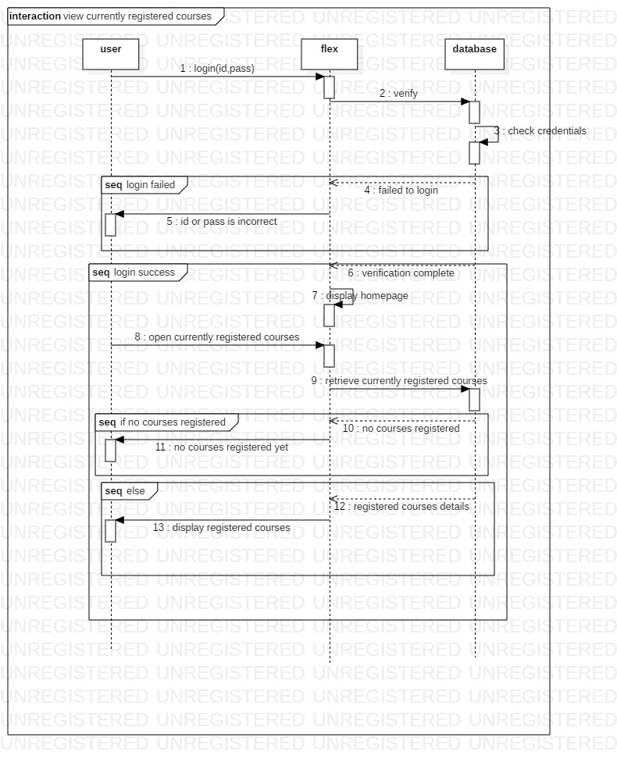

1. View Registerable Courses

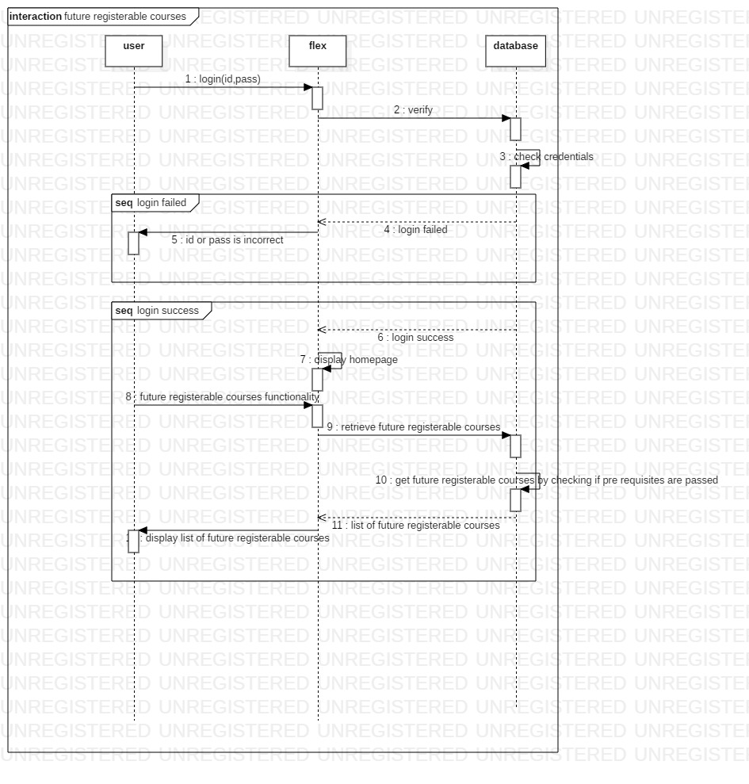

1. Hassaan Zulqarnain
2. Add Student

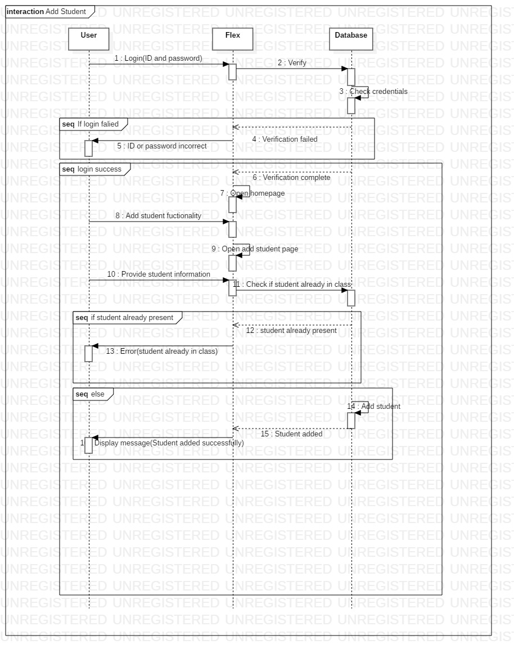

1. Add Student Attendance

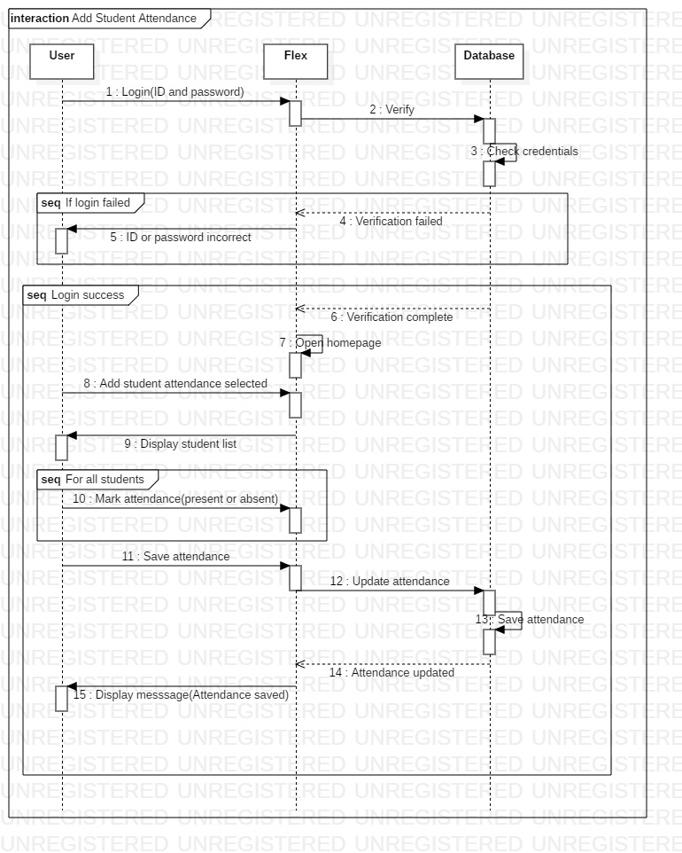

1. View User Information

